MULTIPLE DISTRICT 105
YOUNG AMBASSADOR
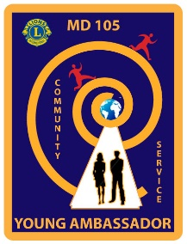
OF THE 21ST CENTURY

CODE OF CONDUCT

Name of Candidate ………………………………………………. District ……….

I recognise that as a candidate for the Young Ambassador of the 21st Century award, I am representing my local Lions Club and the wider family of Lions.

- I will behave always in a way that will enhance the reputation of Lions Clubs International.

- I will not bring Lions Clubs International into disrepute by thoughtless or irresponsible behaviour. This includes adherence to the law in relation to buying and consuming alcohol.

- I will be on time for all the events throughout the weekend and remember to eat breakfast!

- I will not cause unnecessary worry, nor put myself at risk, neither by leaving the hotel, nor will I change bedrooms without notifying the organisers.

- If any problems arise, I will contact the organisers to get support and help.

- I will treat my fellow-candidates with respect and kindness.

- I will use my common sense and above all, enjoy this experience and promote Lions and its awards to my friends and fellow students.

- If I am the winner of the Multiple District Final, I agree to represent the Lions of the British Isles at the Lions MD Convention in …………………………………….. 2021 and compete in the European Final at Europa Forum, Thessaloniki, Greece, 7th – 10th October 2021 and also the MD Young Ambassador finals in February 2022.

Signed: Date:

